The different things I encountered creating my code and which steps I took accordingly

If possible try to use images and plots to substantiate your choices.

Introduction/Summary
Before going into the details of the different steps in the automated ROI detection, I will first give an overview for better understanding of the mechanisms.

For cryo-ET, we need to create a lamella within the sample at the region of interest (ROI). This ROI is found with a fluorescence light microscope (FLM) which is incorporated in the SEM/FIB. To check whether the ROI is still present after FIB milling, we look at the sample through the FLM and measure the fluorescence at the spot of the ROI. If there is no fluorescence left, we FIB-milled the ROI away, if there is still fluorescence, the FIB-milling was successful. This check is done manually, however it would be nice to automate it. That is the goal of my project, to automate the ROI detection after FIB-milling.

The general workflow of this automated ROI detection goes as follows:
1) As input it uses the z-stack/image before and after milling (roughly around the milling site)
a) Z-stacks get projected with a maximum intensity projection.
b) The images get normalized to be able to compare them to each other.
2) It finds the location of where there has been milled and creates a mask of that location.
a) By looking at the differences in fluorescent intensity before and after milling.
b) Or alternatively by finding the lines of the milling site with line detection.
3) It looks if there is any fluorescent signal left within the mask in the image after milling.
a) Noise is filtered out with binary operations after applying a threshold to the image.
b) Blob detection can be used if your ROI has certain specific features.

For more information on the cryo-ET and how the FLM is incorporated, see the website of Delmic:
https://www.delmic.com/en/techniques/cryogenic-electron-microscopy

Reading the image or z-stack
needs to include: pictures of histograms and difference max and mean intensity projections?

The dataset consists of z-stacks and single images in the .tiff and .ome.tiff format. When I first started with the dataset, I manually looked at the z-stacks via Odemis viewer and selected a z-slice from the z-stack which was in focus. For each z-stack this was a different slices number so you could not say: from each z-stack, let’s take slice number 10. Then there was the problem of digital outliers, when I first looked at the images through matplotlib, I saw nothing. Later I found out this was because of the outliers. Where the normal values were from 0 to ~500-10.000, the outliers could get values of up to 65.535. Why this exact upper limit? That is because that is exactly 2^(16) which is the highest value a 16-bit image can get. The cutoff for outliers was also manually chosen at first. For some time I just used these manually chosen values to work out the rest of the steps but after some time the automation of these two steps needed to be implemented (partially because the dataset also got bigger).

So for the automation of picking one image from a z-stack, for simplicity I implemented a mean or maximum intensity projection (MIP). This worked nicely but had some drawbacks, mainly on the memory side of the computer. Z-stacks can be a few hundreds MB in size and when going trough some z-stacks, memory garbage pilled up and the code stopped running at some point. Even after implementing a `del all variables` after every iteration, the memory garbage still pilled up. As a solution I implemented two things: a maximum of slices used and garbage collection. So with the first solution, I assumed that the first and last slices of the z-stack are so out of focus they don’t have any useful contribution to the MIP so they can be disregarded. If the z-stack has more slices than the maximum of slices you tell it to use, the most middle maximum number of slices is used. With this solution, I didn’t really needed the second solution anymore for the dataset I had but if some people have really big datasets, the second solution is still useful, so I still implemented it. At the end of the big for loop of all the z-stacks and images, all the temporary data gets deleted and then with the library Garbage Collector Interface (gc) the memory gets cleaned up. At some point in my dataset this caused an improvement of 10% in memory use at full capacity (8GB of RAM). Another drawback of MIP was that with maximum intensity projection, you have more outlier noise in your image and with mean intensity projection the signal from the in focus slice gets “pulled down” by the absence of signal in the out of focus slices. After looking at both options, I concluded that the maximum intensity projection was better than the mean intensity projection because outlier noise was more easy to filter out than dealing with the lower signal-to-noise ratio (see Figure 1).
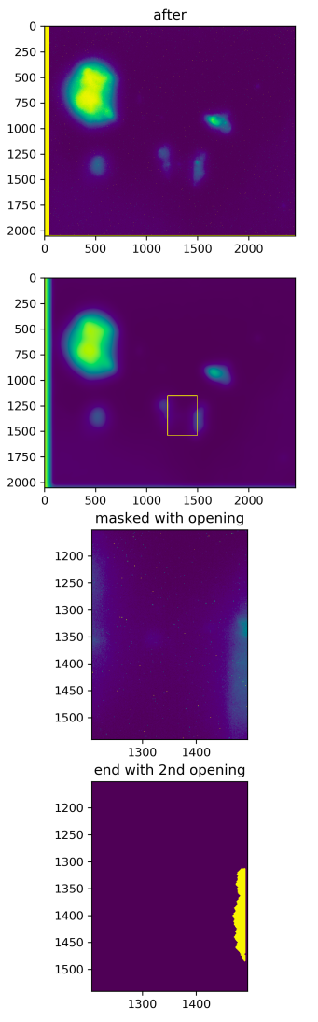
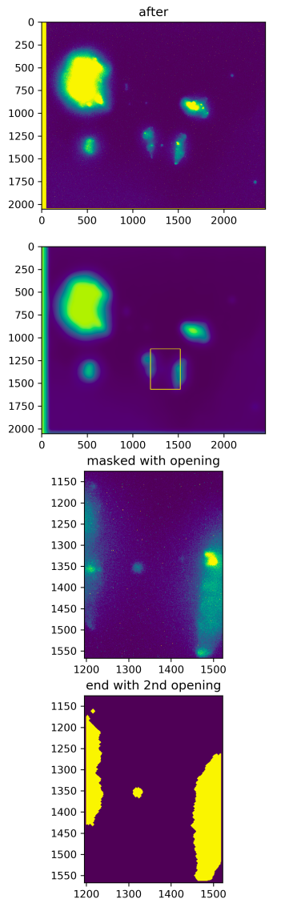
Figure 1: Of the same z-stack after milling on the left a mean intensity projection and on the right a max intensity projection. Here you can clearly see that you can more easily detect signal in a max intensity projection. The intensity scale is different with the mean intensity projection so a different threshold should be used to qualitatively compare the two (which wasn’t done for this picture).

For the automation of the outlier threshold, I first looked if I could just use the 99% of the maximum intensity as a threshold. However this did not work for all the z-stacks as the maximum values varied quite a lot. As a second approach, I tried to look at the histogram of the intensity values. I made a cumulative normalized histogram and made a cutoff at 99% of all the pixels. This worked way better and often even gave the same threshold as was set manually. So this was in the end the way to go for the outlier cutoff threshold.

Insert pictures of histograms.

Re-scaling and shifting
Already very soon I noticed that sometimes the z-stack before milling had a different resolution and image pixel size than the z-stack after milling. To be able to look at the differences between the two images, they need the same pixel size. As a solution, I implemented an interpolation such that the lower resolution image had the same number of pixels as the higher resolution image. In this way, nothing qualitatively changed and the images could be properly compared.

Next to the different resolutions / pixel sizes, there was also a shift in the image after milling compared to the image before milling. This is due to the fact that the stage needs to move towards the SEM/FIB place and back towards the METEOR spot. The mechanical uncertainties give rise to a shift in the image after the milling. So, this needs to be accounted for, but how? First, I wanted to use the metadata of the images to calculate the shift, but after some experimentation I noticed that the metadata was mostly not correct and not accurate (especially in the z-axis position, there were shifts found of hundreds slices while the z-stacks only had 30-70 slices, see figure 2). So instead of using the metadata, I implemented a convolution between the two images. With finding the maximum in the convolution, you could find the shift of the image after milling. This worked nicely and seemed to be more accurate. However for some images, due to the shift, other fluorescent signal came into the image, which sometimes gave rise to the wrong shift. To account for this, I assumed that the images roughly overlap and that shifts bigger than 1/x of the image cannot occur (so the best next option gets chosen). This x is a parameter that you can change yourself (in the function itself the 1/x works a bit different but the essence is the same). If in the future with new data, this convolution method does not work, SIFT could be a good alternative (not implemented).

After the image after milling was shifted to the right position, then the pixels that fell outside of the shifted image boundary were given the maximum intensity value of the image. In this way, these pixels would not be used anymore in the next steps of the automated ROI detection.
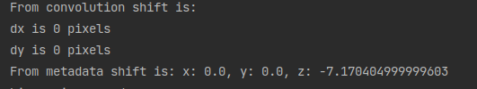
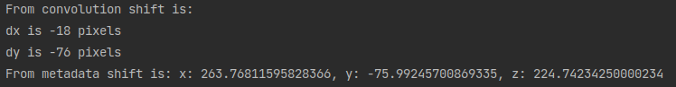
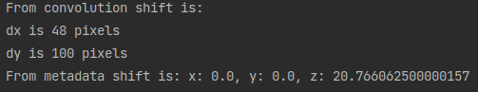
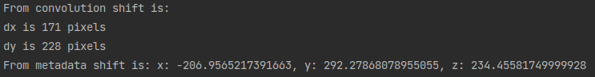
Figure 2: Different shifts from different images calculated via the convolution and via the metadata. (je kan hier nog de daadwerkelijke images bij laten zien, maar ik denk dat ze mij hier wel op kunnen geloven)

Normalizing and blurring
After milling, the fluorescence in the sample at that spot has decreased significantly. Because of this, researchers sometimes use a higher illumination intensity to still see the fluorescence above the noise. This works for the researchers but here if you want to compare the image before and after milling, the intensity scales are sometimes very different (see figure 3). So we need to account for these different intensity scales. This is done with a normalization in both images to go to a range of 0 to 1. In this way we can easily compare them and look at the differences quantitatively (see figure 4). I actually did not use the full range of the images to normalize it. This is because there is a constant background intensity which we can get rid of with finding the minimum intensity of a blurred image. Why the blurred image? Because with noise you still have relatively large variations in this background intensity (e.g. you have a background level of 70 but with the noise the minimal intensity is 0). With blurring the image, you account for the noise and get rid of it. Then you do find the minimum to be the background intensity level instead of just zero. In this way, going from background level to max intensity instead of going from zero to max intensity, the highest contrast is achieved with the normalization. Everything below the background level is just set to zero because that is probably noise.
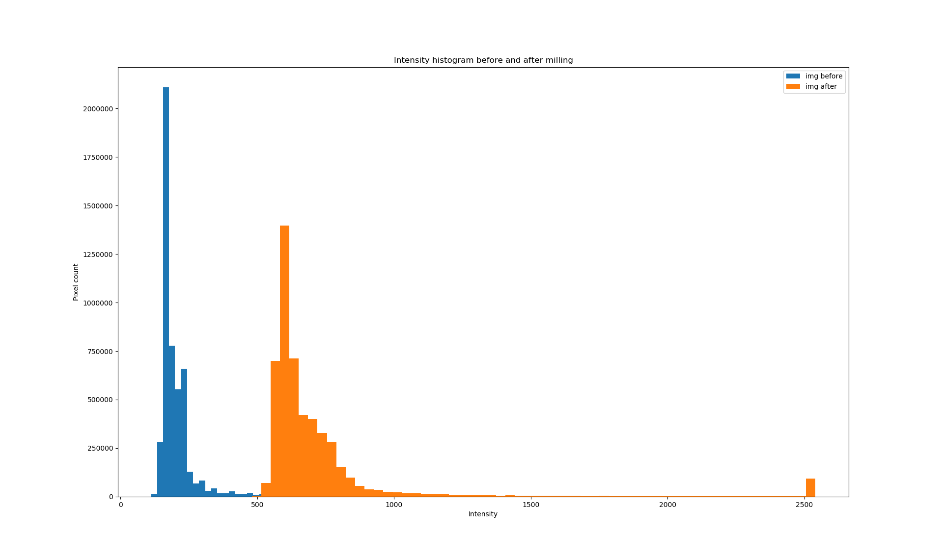
Figure 3: Intensity histogram before and after milling without normalization. The image after milling has higher intensity values than the image before milling.
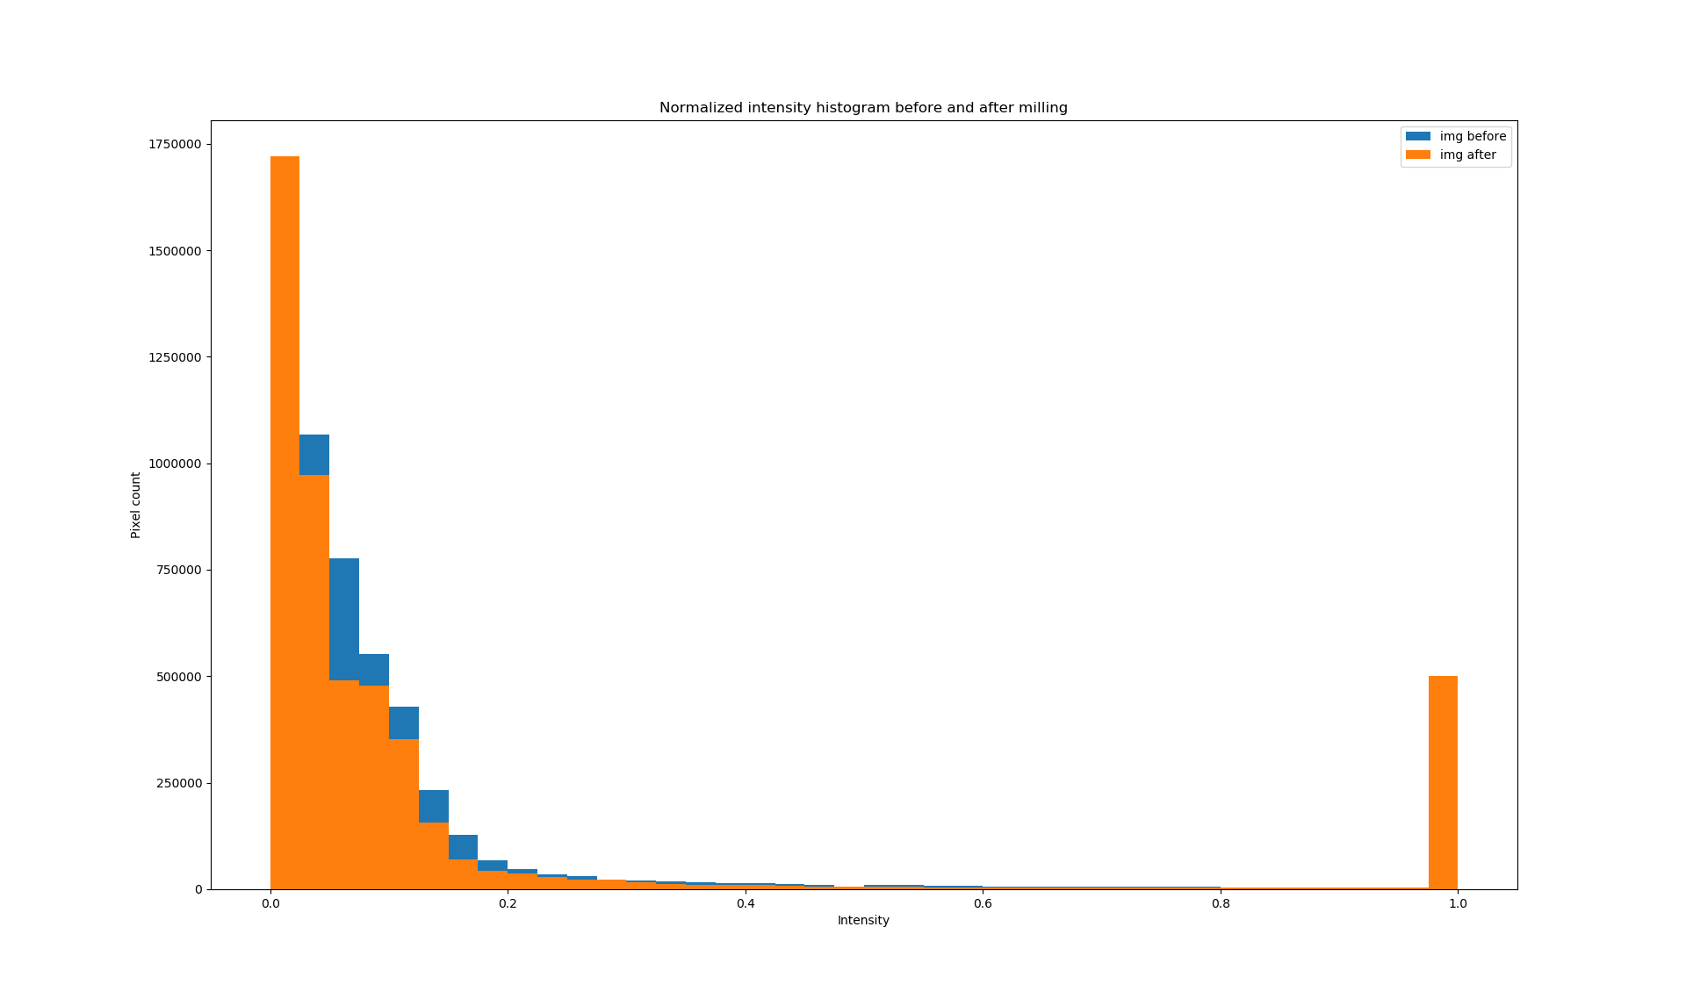
Figure 4: The normalized intensity histogram of the images before and after milling. The intensity profiles are quite similar, which we want to compare the two.

Next to the normalization, the blurred images are also used for detecting where the ROI is with the differences in intensity. This is because the location detection is not detail orientated so blurred images are preferred (then the noise is better suppressed). See next section for more information.

Mask creation with the difference
So the first way to create a mask of the ROI location is to look at the differences between the image before and after milling. Here I used the blurred images because you want to look at larger regions of intensity differences and not at very small spots. With blurring you get rid of small local intensity changes (mostly caused by noise). The difference between the images is calculated with just a simple subtraction of before minus after. A threshold is applied to the difference and we get a boolean image which represents the mask. Sometimes, small spots of intensity differences still get through the threshold so a few binary operations are performed on the mask to get rid of too small regions. First, a binary opening is performed to get rid of too small regions in the boolean mask (see figure x). Secondly, an binary erosion can be optionally performed to get rid of signal on the boundaries of the mask (see figure x+0.5, not sure if I want to implement this). Lastly, the mask can be made a square to represent the milling site more closely, this is done with finding the maxima and minima of the mask and use that as the boundaries of the square (see figure x+1). In most cases it seems that squaring the mask is beneficial (see figure x+2), however sometimes there are still multiple regions in the mask that create a square almost as big as the image itself (see figure x+3). As a solution to this, I implemented a constraint to how big the mask can be so if squaring makes it bigger than the maximum, it will not be squared (this is commented right now in the code to be able to make figure x+3).

Line detection

Mask creation with the lines and the difference
When there are more than 2 groups passed through the line detection, you can choose to use all of them or only the first 2 of them to create the boundaries of the estimated milling site. Weirdly enough it seems that instead of using all the groups, only using the first two groups works better.

Final threshold for detecting signal within the mask
needs to include: binary operations

Circle detection became blob detection

Plotting end results

Garbage collection?

